# Instruction for Predicting SLM Multi-Layers Spreading Powder Process by Using Yade

## I. Preparation before calculation

1. The SLM spreading powder process is predicted by Yade. Therefore, Yade needs to be installed before calculation (refer to the official Yade instructions, link: https://yade-dem.org/doc/installation.html);
2. Copy the example folder "multiLayerSpreadPowderSLM_Yade" to any local location.

## II. Calculation process

1. The example folder "multiLayerSpreadPowderSLM_Yade" contains three folders: "Layer1", "Layer2" and "Layer3", which correspond to the first layer, the second layer and the third layer of the spreading powder process;
2. Enter the folder "Layer1", run the command "yade -j32 Layer1.py" (here 32 refers to the number of cores used for parallel computation, which can be modified depending on your computer configuration), and click the Start button. At the end of the calculation, the particle information of the powder bed area will be output;

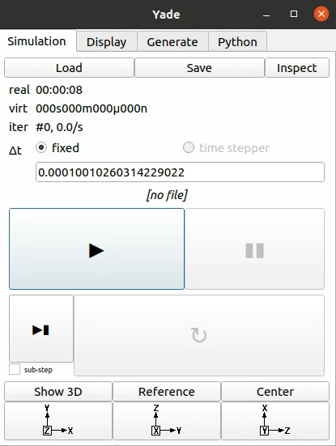

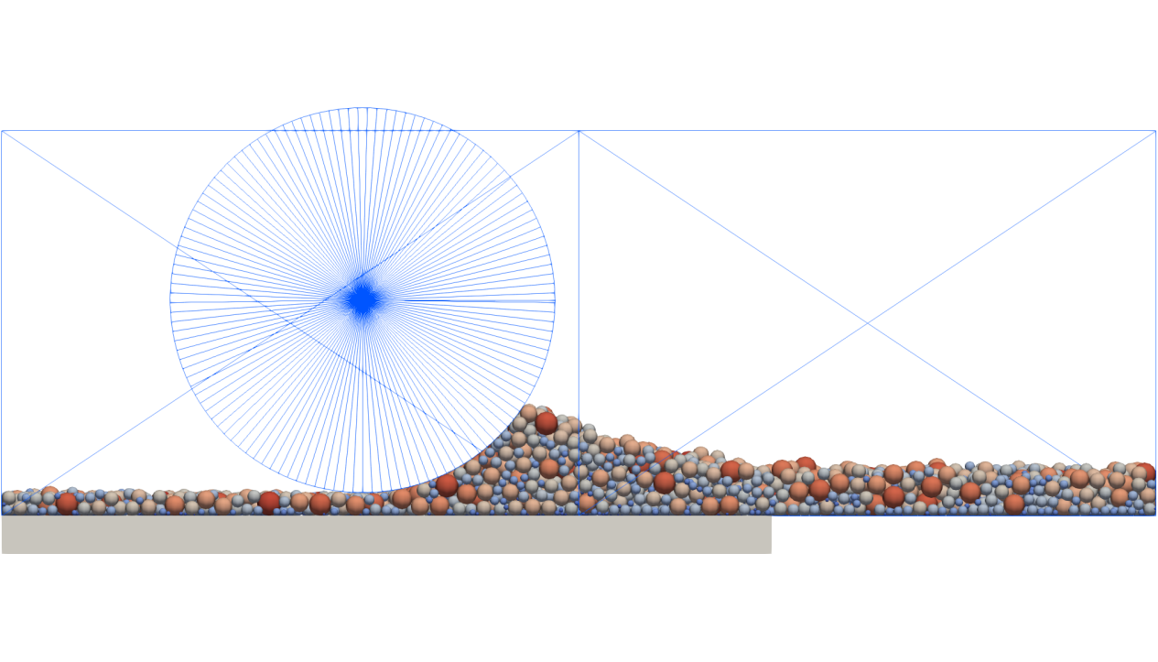

1. Enter the folder "Layer2", run the command "yade -j32 Layer2.py" (here 32 refers to the number of cores used in parallel computation, which can be modified according to your own computer configuration), and click on the start button. After the end of the calculation, it will output the particle information of the powder bed area (it should be noted that the second layer of the powder needs to use the melt channel shape after forming the first layer. Here contour_layer1.stl is this shape, and contour_layer1.stl needs to be extracted by using OpenFOAM to form the first layer);

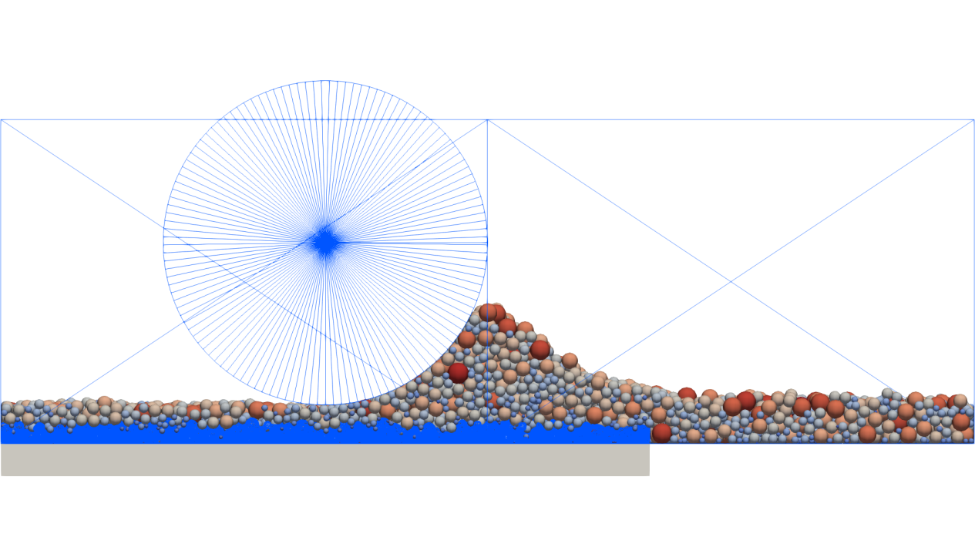

1. Enter the folder "Layer3", run the command "yade -j32 Layer3.py" (here 32 refers to the number of cores used in parallel computation, which can be modified according to your own computer configuration), and click on the start button. After the end of the calculation, it will output the particle information of the powder bed area (it should be noted that the third layer of the powder needs to use the melt channel shape after forming the second layer. Here contour_layer2.stl is this shape, and contour_layer2.stl needs to be extracted by using OpenFOAM to form the second layer).